NOTICE OF PUBLIC HEARING

The Lee County Commissioners Court will hold a Public Hearing on April 15, 2024, at 10:00 a.m. at the City of Giddings Council Chambers, 118 E. Richmond, Giddings, Texas to consider the following items pursuant to the provisions of the Property Redevelopment and Tax Abatement Act, Chapter 312 of the Texas Tax Code: (1) the application of BT Brown Solar, LLC, declaring eligibility to participate in tax abatement, designating a certain area of Lee County, Texas as a Reinvestment Zone for Tax Abatement to be known as the Lee County Reinvestment Zone-Brown Solar, establishing the boundaries thereof, and providing for an effective date for the creation of said zone; and (2) the approval of a Road Use Agreement, and (3) the acceptance of an Application for Lee County to enter into a Tax Abatement Agreement with BT Brown Solar, LLC for a 50 MW solar generating facility, with a 30 MW battery energy storage system, at an estimated cost of $77,500,000.00 dollars,

For the creation of a reinvestment zone as set forth in the Property Redevelopment and Tax Abatement Act, the Commissioners Court will consider whether the designation would contribute to the retention or expansion of primary employment; would attract major investment that would be a benefit to the zoned property; would contribute to the economic development of Lee County; or would otherwise have a positive impact on the County or its residents.

In determining whether to accept the Application for the Reinvestment Zone and Tax Abatement, the Commissioners Court will consider the criteria established in the Lee County Reinvestment Zone and Tax Abatement Guidelines.

The Public Hearing will take place on April 15, 2024 at 10:00 a.m. at the City of Giddings Council Chambers, 118 E. Richmond, Giddings, Texas. All interested persons may appear and present testimony and evidence regarding designation of the Reinvestment Zone and acceptance of the Application for Tax Abatement.

The Commissioners Court will consider and act on the Reinvestment Zone and Tax Abatement Application at the regular Commissioners Court meeting at 10:00 AM on April 22, 2024, at the Lee County District Courtroom, 289 South Main, Giddings, Texas.

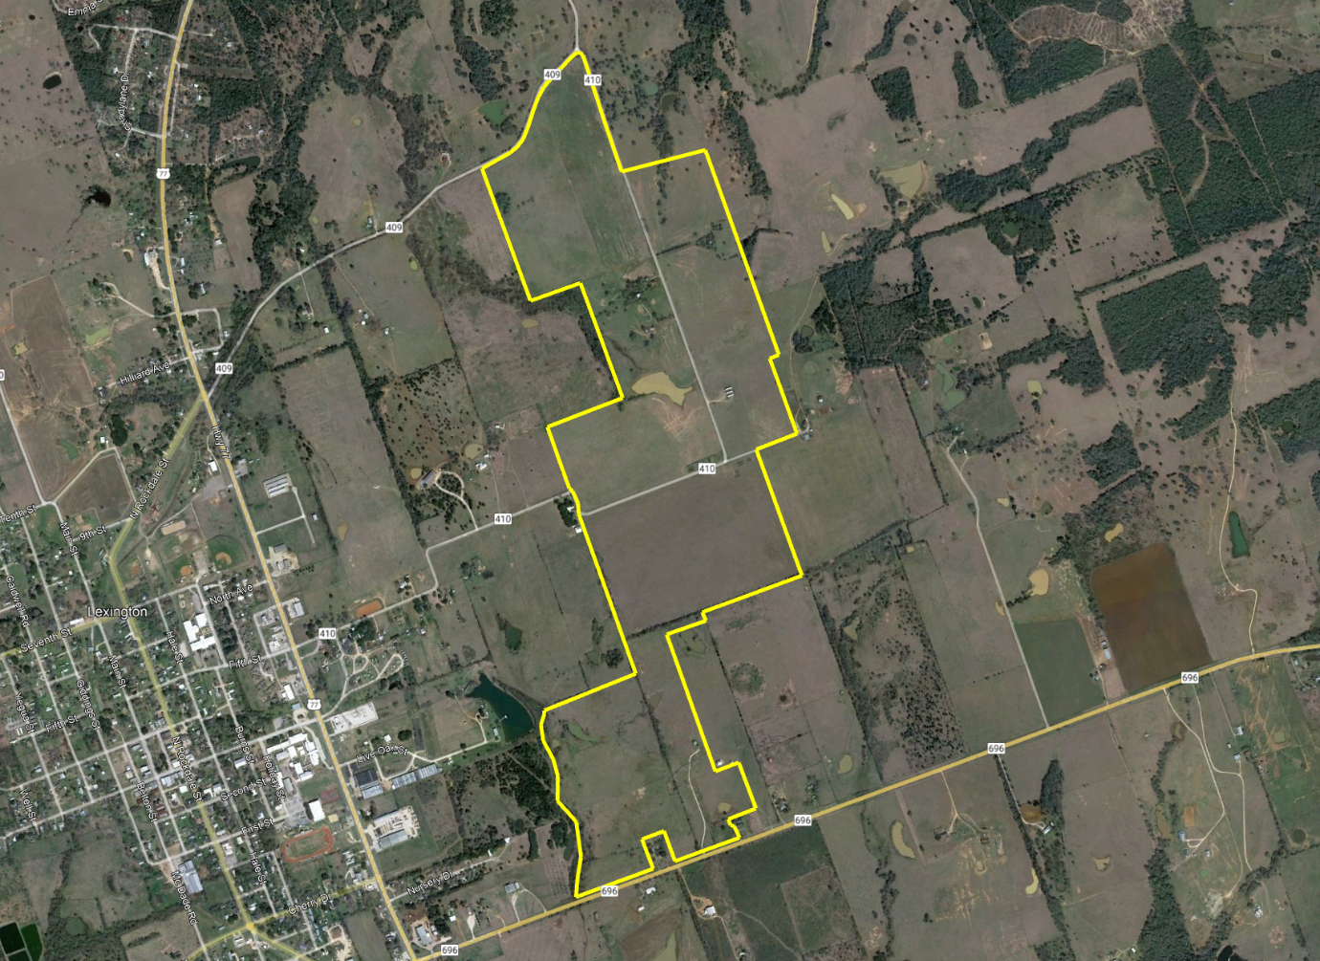

Property East of Lexington, Tx
